**MILESTONE 5 – PROCESS MODELING - Part II (Exploded DFD)**

**Part 1**

System Data Flow Diagram:

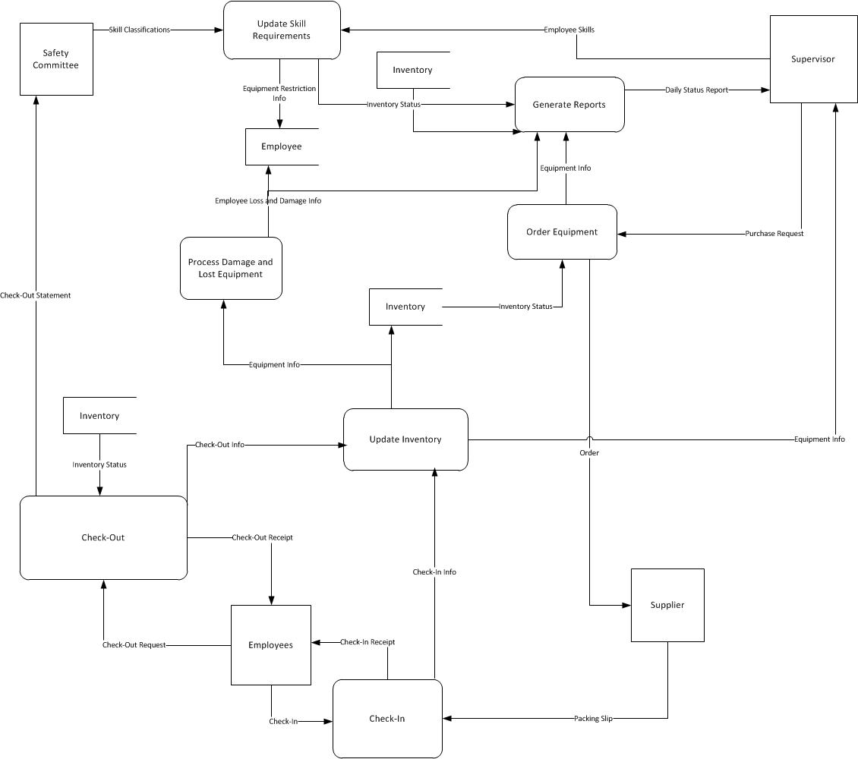

Primitive/Child Data Flow Diagram:

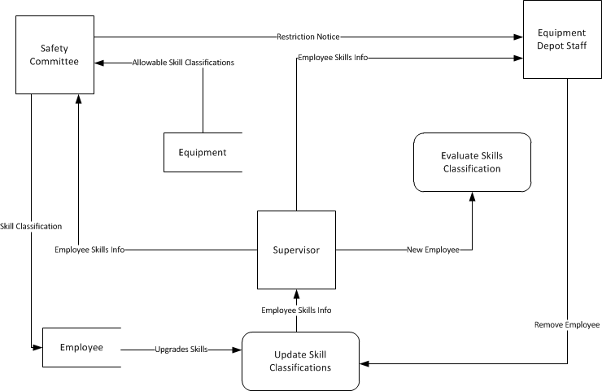

**Part 2**

Structured English:

Read Allowable_Skill_Classifications record from Equipment file. AT END

SET End of file 1 indicator to TRUE

Read Employee_Skills_Info record from Supervisor file. AT END

SET End of file 2 indicator to TRUE

Send Skill Classification to Employee

If Employee is Upgrades_Skills THEN

SET Update_Skill_Classifications to TRUE

Else Update Skill Classifications File with Employee information

If Update_Skill_Classifications is True,

Send Employee_Skills_Info to Supervisor file

Read New_Employee record from Supervisor file

SET End of file 1 to true

If end of file 1 true

Read Evaluate_Skills_Classification

Send Evaluate_Skills_Classification to Supervisor file

Read Employee_Skills_Info from Supervisor file

If end of file 1 true

Send Employee_Skills_Info to Equipment Depot Staff file

Read Remove_Employee record from Equipment Depot Staff file

If end of file 1 indicator is true

Update Skill Classifications file

Read Restriction_Notice from Safety Committee file

If end of file 1 true

Send allowable skill classification from equipment to Equipment depot staff file

Update Skill Classifications